Why fan coil units?
Fan coil units have been selected to provide local heating and cooling for many years and there are still many positive attributes that justify the choice of a fan coil unit system today. It is necessary for manufacturers of these products to constantly respond to changing market demands and satisfy increasingly stringent legislation, in particular that regarding energy consumption. Rather than this legislation resulting in the demise of the fan coil unit, it has prompted manufacturers to take ever more innovative approaches to their design, as well as consider the advantages proffered by entire heating and cooling systems. As such, advances in the technology applicable to both this product and those that complement it have resulted in the resurgence of the fan coil unit.
This document is intended to bring to the attention of the reader the many advantages of fan coil unit systems, which are summarized and compared with the attributes of alternative systems in the table shown below.

Attributes  Attribute | System
 | Fan coil unit | Active chilled beam | Passive chilled Beam | Variable refrigerant flow (VRF) | Variable air volume (VAV) | All Air
Cooling medium | Low grade CHW  High grade CHW | Primary air  Low grade CHW | Low grade CHW | Refrigerant | Primary air  Low grade CHW  High grade CHW | Primary air  Low grade CHW  High grade CHW
Heating medium | Low grade LTHW High grade LTHW Electric | Low grade LTHW | N/A | Refrigerant | Primary air  Low grade LTHW High grade LTHW | Primary air  Low grade LTHW  High grade LTHW
Physical size | Compact | Large | Large | Compact | Large system | Large system
Positioning | Exposed  Integrated  Concealed | Exposed  Integrated  Concealed | Exposed | Exposed  Integrated  Concealed | Concealed | Concealed
Terminal unit position | Wall  Ceiling  Underfloor | Ceiling | Ceiling | Wall  Ceiling  Underfloor | Wall  Ceiling  Underfloor | Wall  Ceiling  Underfloor
Sound levels | Quiet | Quiet | Silent | Quiet | Quiet | Quiet
System energy consumption | Low | Very low | Ultra low but needs separate primary air supply | Low | High | High
Control | Air volume flow rate Water mass flow rate | Water mass flow rate  Air volume flow rate | Water mass flow rate | Air volume flow rate  Refrigerant mass flow Rate | Air volume flow rate | Air volume flow rate
Response | Fast Subtle | Medium Subtle | Slow  Subtle | Fast  Aggressive | Medium Subtle | Medium  Subtle
Flexibility | High | Medium | Medium | Medium | Low | Low
Terminal unit dehumidification | Consequential with high grade CHW | None | None | Consequential | None | None
Air distribution | Very good via ductwork and diffusers | Good via integral diffuser | Moderate | Very good via ductwork and diffusers | Very good via ductwork and diffusers | Very good via ductwork and diffusers
Maintenance | Medium | Low | None | High | Low | Low
Local air filtration | Yes | No Primary plant filtration | No | Yes | No Primary plant filtration | No Primary plant filtration
Fresh air handling terminal unit | Yes | Yes | No Needs separate primary air supply | Yes | Yes | Yes
Potential for off-site assembly | High | Very high for multi- service chilled beams | Very high for multi- service chilled beams | High | Low | None
Global warming potential (GWP) | Low | Low | Low | High | Low | Low
Summary | + Flexible Controllable Proven technology  - Medium maintenance level  Removal of condensate | + Multiservice variant Quiet  Low maintenance  - Inflexible in multiservice format  High primary air  volume | +Multiservice variant Silent  Énergy efficient  Maintenance free  - Low output Needs separate primary air supply | + Preconfigured system Compact  Controllable  - Contain refrigerant gas  Aggressive response | + Low maintenance Relatively simple unit  High energy consumption  Large ductwork | + No terminal units Simple system  Low maintenance  - High energy consumption  L Large ductwork

1) Why water based fan coils?
Although, fan coil units may utilise a medium of either chilled water (CHW) or refrigerant to provide cooling, they are primarily associated with chilled water. The principal advantage of installing a fan coil unit system that wholly employs water as the cooling medium is that there is no need for the specific checking and maintenance demanded by the F Gas regulations pertaining to those installations that necessitate the presence of refrigerant within the building envelope.
2) Cooling medium
Fan coil units can utilise slightly lower grade chilled water (i.e. >10⁰C flow) than that traditionally employed and are hence, in cooling mode, capable of providing cooling in conjunction with a reverse cycle heat pump or making use of free cooling from either a free cooling chiller or dry cooler. Refer to item 9 for ease of control.

3) Heating medium
Similar to the cooling medium, although fan coil units are capable of providing heating using either hot water or refrigerant, they are typically supplied with low temperature hot water (LTHW). The principal advantage again being that the use of water as the heating medium negates the need in VRF for the specific checking and maintenance demanded by the F Gas regulations pertaining to those installations that necessitate the presence of refrigerant within the building envelope.
Fan coil units can function using much lower grade hot water (i.e. < 55⁰C flow) than that traditionally employed and are therefore capable providing heating in conjunction with condensing boilers or heat pumps.

4) Renewable Energy compatibility
Fan coil units are compatible with, and can be used with, renewable energy systems.

5) Physical size
Fan coil units have large maximum cooling and heating outputs and therefore they afford the installer a cooling and heating solution that is compact in physical size. Areas that have a large heating or cooling requirement may be serviced by either a small number of large fan coil units or a large number of small fan coil units. Low quantities of fan coil units minimises initial system capital cost and space required for the terminal unit installation whereas high quantities of fan coil units provide the flexibility to easily change building layouts and there may be the potential to reduce system operating costs. Fan coil units may be fitted even in buildings that have a ceiling void of restricted depth, many manufacturers offering slimline products for concealed installation or cased units for exposed installation directly to either the walls or soffit.

6) Positioning
Fan coil units are available in many guises, including with a self-finish galvanized steel chassis or a painted casing, lending themselves to concealed installation. Alternatively should there be no available space for false ceilings, walls or architectural casings then exposed installation can be used.

7) Terminal unit position
Further to options for concealed or exposed installation, fan coil units are also available in either a vertical or horizontal orientation and the locations in which fan coil units may be installed are almost limitless as a result. Fan coil units may be positioned vertically against walls, horizontally against soffits or even with access from above beneath false floors.

8) Sound levels
Fan coil unit systems correctly installed with the optimum quantity of quality diffusers produce little noise. Fan coil unit systems can be desirable over silent cooling and heating solutions since they produce a background sound level that is both low enough not to be intrusive but sufficiently high to provide privacy between adjacent rooms. Larger fan coil units operating at lower speeds and with attenuators fitted may be selected to satisfy more stringent acoustic requirements. Fan coil units sized correctly can meet the specified critical noise requirements of residential building and hotel bedroom applications .

9) System energy consumption
Fan coil units, incorporating EC fans, are very efficient and remain well within the requirements of the Building Regulations Part L Non-Domestic Building Services Compliance Guide 2013 Edition. Adding variable fan speed strategies, unoccupied setbacks etc. reduces consumption yet further. In a like for like situation other systems may still have a slight edge with energy consumption over fan coils but then EC fan coils can react to the demands of individual areas making a whole fan coil system, through its flexibility, more efficient.

10) Control
Fan coil control units effect output by varying both air volume and water volume. Modern strategies can intelligently control both these mediums to give a subtle but, if need be, fast response time to environmental changes. Because a fan coil system is a collection of many fan coils, and because each fan coil can act autonomously, a fan coil system can respond to many different demands at the same time making it, very controllable and flexible.

11) Response
Fan coils are generally required to hold a particular temperature and will do so to quite a fine tolerance. However, fan coils will also respond to a temperature change demand in a matter of minutes. This makes them suitable for larger, single temperature spaces and individual office type spaces where temperature variations may be required by the occupant. Some other systems (see table above) can be conversely, comparatively slow to respond, and are therefore generally better suited to large open plan areas where a fairly stable temperature is required.

12) Flexibility
Fan coils are a self-contained product connected to other services by only 2 or 4 water pipes and an electrical connection. Fan coils are therefore very flexible in terms of their size, configuration and their ultimate location. Alternative systems are generally physically larger and therefore less flexible. Fan coils can also be easily moved and reconfigured at fit out where other systems must remain as installed. VRF terminal units are a self-contained item that are connected by refrigerant piping and electrical cable. The size of and the routing of the refrigerant piping usually defines where the terminal units can be placed. These refrigerant pipes are constrained by size and distance and are not as flexible as fan coil water pipes. Fan coil installations are not subject to such rigorous inspection requirements as they only use water. See the table above for the detailed system comparisons.

13) Terminal unit dehumidification
Fan coils, if selected with sufficiently cold water will remove moisture from the conditioned air. The amount of dehumidification is not precise however, due to the ever changing humidity levels, and so should be considered simply a byproduct of the conditioning process rather that a calculable feature. It is normal to fit fan coils with drip trays and suitable drainage. However fan coils can be selected to 'run dry' if the water temperatures are comparatively high. Other systems by design must not create condensate and therefore have no dehumidification effect. It should be noted that all air systems will have humidity control in the Air Handling Units. With the low temperatures involved with refrigerant based systems, condensate creation is inevitable and can be substantial. This must be dealt with and may necessitate specialised systems such as mechanical pumped removal.

14) Air distribution
A fan coil system is one of the most versatile ways of providing conditioned air into a space, not only because it has a small foot print or great controllability but also because it can be mated with a whole variety of grilles and diffusers to match the vision of the architect or interior designer. It also allows the conditioned air to be moved around the served space via discharge ducts, to allow a single unit to distribute to a large and varied area. To ensure the best internal climate is achieved there are a few basic rules that need to be followed. These include ensuring that the discharge velocity within the supply duct is below 3m/s, that the air-off temperature is above 10°C and that whatever grilles/diffusers are selected they match the air volume, throw pattern and room noise level to meet the specification.

Figure 1: Typical fan coil unit installation.
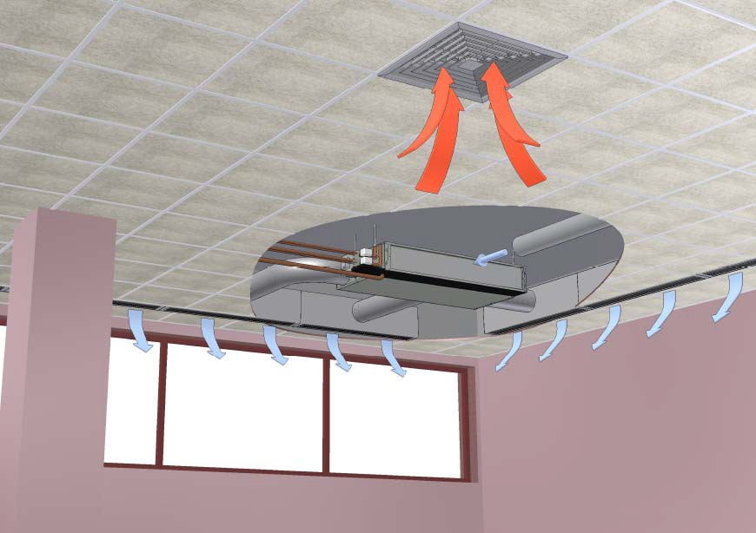
15) Maintenance
Fan coil maintenance is required to ensure the unit runs at optimum efficiency year round, the main item is the units filter, which needs either changing/washing or vacuuming at regular intervals to match the site conditions. If the filter is not cleaned regularly then there will be reduce supply air due to the increased pressure on the fan, causing lower cooling/heating outputs. Other items that need inspection on an occasional basis are the fans, coils and drain tray to ensure they are clear from debris. Maintenance however is strongly recommended but not mandatory unlike VRF systems that under the F gas regulations need all joints to be inspected every 3 months on large systems.

16) Local air filtration
All fan coil units are supplied with a filter whether that be a G3 (EU3) media filter or G2 (EU2) mesh, made from either expanded/perforated sheet metal or plastic. Note there is now a new filter test standard EN ISO 16890 to this standard fan coil filters are typically ISO coarse ≥ 30% The role of the filter is to stop small dust particles from coating the internal surfaces of the heat exchanger and fan. This would reduce their efficiencies and over time cause them to stop working. The filter has the added benefit of cleaning the re-circulated room air, giving the occupants a cleaner and healthier environment.

17) Fresh air handling terminal unit
In most cases fresh air is delivered to the rear of the Fan coil unit, which mixes this air with the re-circulated air from the space and delivers it to the room, the benefit being that that the fresh air is conditioned before it is delivered, eliminating drafts and cold spots.

18) Potential for off-site assembly
Due to time constraints, off site fabrication has become increasingly popular, firstly fan coil manufactures fitted air vents, drain cocks, discharge plenum, and then controls giving a fully packaged unit. Recently we have seen hanging system, valve arrangements and network connectors fitted to the units before they reach site. This reduces onsite installation times and costs as it is much faster and simpler to fit many of theses systems on the bench than up in the air. This demonstrates the versatility of fan coils and especially UK built units, as they have the ability to provide bespoke solutions to the customer.

19) Global warming potential (GWP)
Fan coil units generally utilise water as a cooling medium and either water or electricity as the heating medium, a direct consequence of which is that fan coil unit systems contain refrigerant in larger items of plant that are typically installed external to the building envelope, e.g. chillers or heat pumps. The global warming potential of fan coil unit systems is therefore correspondingly minimal; another illustration of how the use of fan coil unit systems over alternative heating and cooling systems may serve to benefit our environment

