**Electronically Commutated Motors**

Electronically commutated (EC) motors, also known as BLDC (brush-less direct current) motors are synchronous motors where a direct current supply is converted to drive each phase in the motor windings, via an inverter or a switching power supply

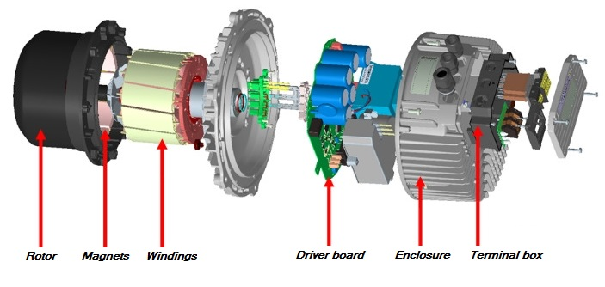

*Diagram 1: Exploded view of the main components in a typical EC motor used in HVAC applications.*

They are a proven technology, developed from “brushed” DC motors in the 1960’s and 1970’s, when solid state electronics enabled the replacement of noisy, inefficient and unreliable commutators and brushes with transistor circuits to switch the current through the motor windings, these motors are often referred to as electronically commutated or EC motors. Further developments of magnets and microprocessor control have led to the EC motors in their present form being commercially available form of construction.

With more widespread use and improved economies of scale, the cost of EC motors is now comparable to their equivalent capacitor start/run asynchronous AC motors.

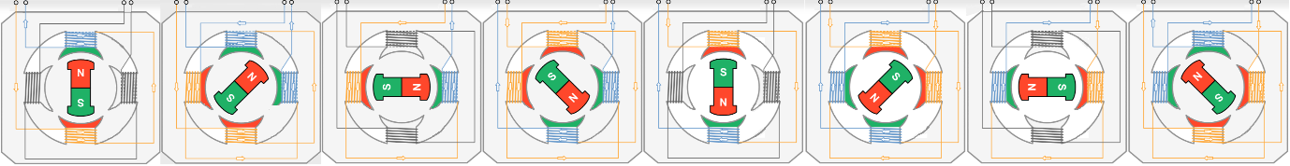

*Diagram 2: Simple sequential schematic, showing how the windings in a brushless DC motor are energised and result in rotation of the rotor. On the motor windings, south is shaded green and north is orange, illustrating how the magnetic fields rotate as the voltage on the windings is varied.*

‘Traditional’ AC asynchronous motors are normally single speed devices, where speed is varied or controlled by varying the voltage of the AC supply to the motor windings, or multi-tap motors, where fan speed is varied by selecting the relevant tapping point of the motor winding. For cost-effective applications, this would be limited by using a multi-tapped autotransformer or around 5No tapping points on the motor winding, which provides a limited number of discrete voltages. Commercially available EC motors include the driver or controller board, where speed control is infinitely variable using an analogue control input, usually 0 – 10 Vdc. In addition, the on-board microprocessor allows the motor characteristics to be set to give the desired feature, i.e. constant speed, constant flow rate, constant pressure, etc or a bespoke fan curve. On most, if not all, applications the motor driver board provides a fixed 10Vdc output thus allowing a potentiometer (usually 10k) to be used to create the control input, if desired.

In fan coil units, EC motors enable a form of ‘variable air volume’ (VAV) control, where a BMS system, or similar, can modulate the airflow rate, as well as water flow rate, between a present maximum and minimum air volume flow rate to meet the actual heating or cooling demand thus saving energy, reducing noise and increasing life expectancy.



*Diagram 3: A typical VAV fan coil strategy to reduce energy consumption.*

EC motors are more energy-efficient, typically consuming half the energy of a traditional fraction horse AC asynchronous equivalent. For fan coil unit applications, energy efficiency is often expressed as power consumption for a given airflow rate, specific fan power (SFP), with the common unit of measure in Watts per litre per second of airflow (W/(l.s)).

EC motors can provide the same degree of speed control and energy efficiency as Variable Frequency Drives (VFD) on AC motors but will reveal inefficiencies that VFD drives may conceal.

The microprocessor might need to know the motor speed in order for the microprocessor to adjust the current to the windings accordingly, this input can be reproduced as a pulsed output, or ‘tacho output’, to enable the fan speed to be externally monitored by a suitable device. This is especially useful when a VAV control algorithm is used as traditional fan proving switches and current switches cannot differentiate between low speed and fan failure

EC motors are compact, complete with the controller board mounted inside the motor frame or enclosure. Their design can be applied to traditional fans with single, double and even triple shaft mounted impellors, or they can be used inside more compact external-rotor motor driven fans.

Power supplies for EC motors (and fan coil units) should be good quality and to recognised standards; similarly, switching devices (including relays, contactors) should be sized appropriately for any resulting in-rush currents of the necessary switch mode power supplies. EC motor controllers normally include devices to minimise the in-rush currents to acceptable levels, but it should be noted that this a capacitive characteristic not inductive as was the case with AC motors.